The Chair



Catalog
The Chair 1
PROJECT DESCRIPTION 3
PROJECT FEATURES 4
TECH STACK 5
MOCK UPS 6

PROJECT DESCRIPTION
The Chair is an Android-based e-commerce application designed to connect hair care professionals with clients in their local area. The app bridges the gap between individuals seeking hair services and professionals such as barbers, locticians, and stylists.
Users can search for specific hairstyles, browse photos of a professional’s previous work, and book appointments directly within the app. Professionals, on the other hand, can create profiles, upload images showcasing their styles, list their specialties, and manage client bookings seamlessly.
The application integrates Google Maps API to allow users to locate nearby hair professionals and uses Firebase as its real-time backend to store and synchronize data between clients and professionals.

PROJECT FEATURES

- User Profiles: Separate account types for clients and professionals.
- Search & Discovery: Find nearby professionals using Google Maps integration.
- Portfolio View: Browse professionals’ photos and listed styles.
- Appointment Booking: Schedule appointments directly through the app.
- Real-Time Database: Firebase enables instant synchronization of bookings, profiles, and updates.

TECH STACK
- Platform: Android Studio
- Language: Java
- Backend Database: Firebase Firestore
- Cloud Storage: Firebase Storage
- Location Services: Google Maps API
- Authentication: Firebase Authentication

MOCK UPS
Login and Sign up flow
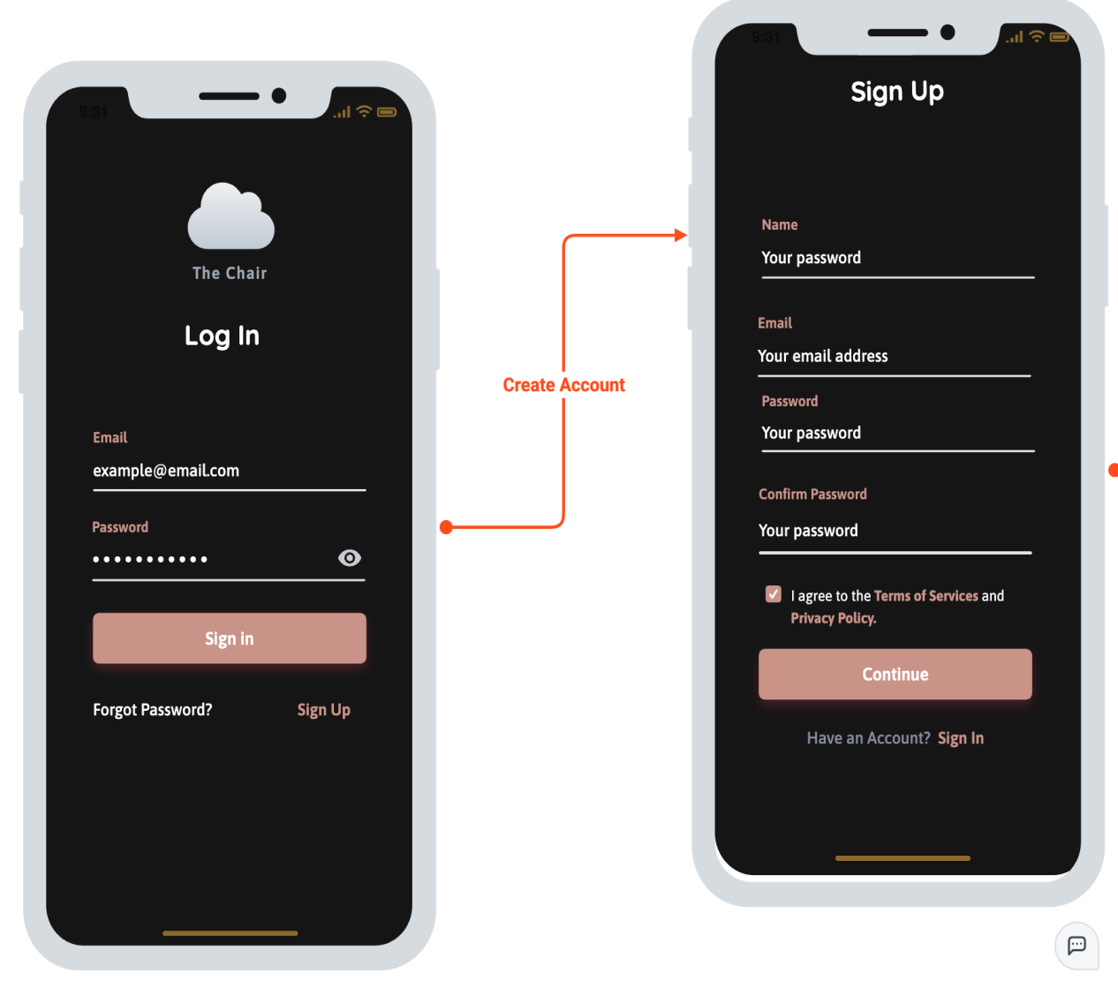

User type decision
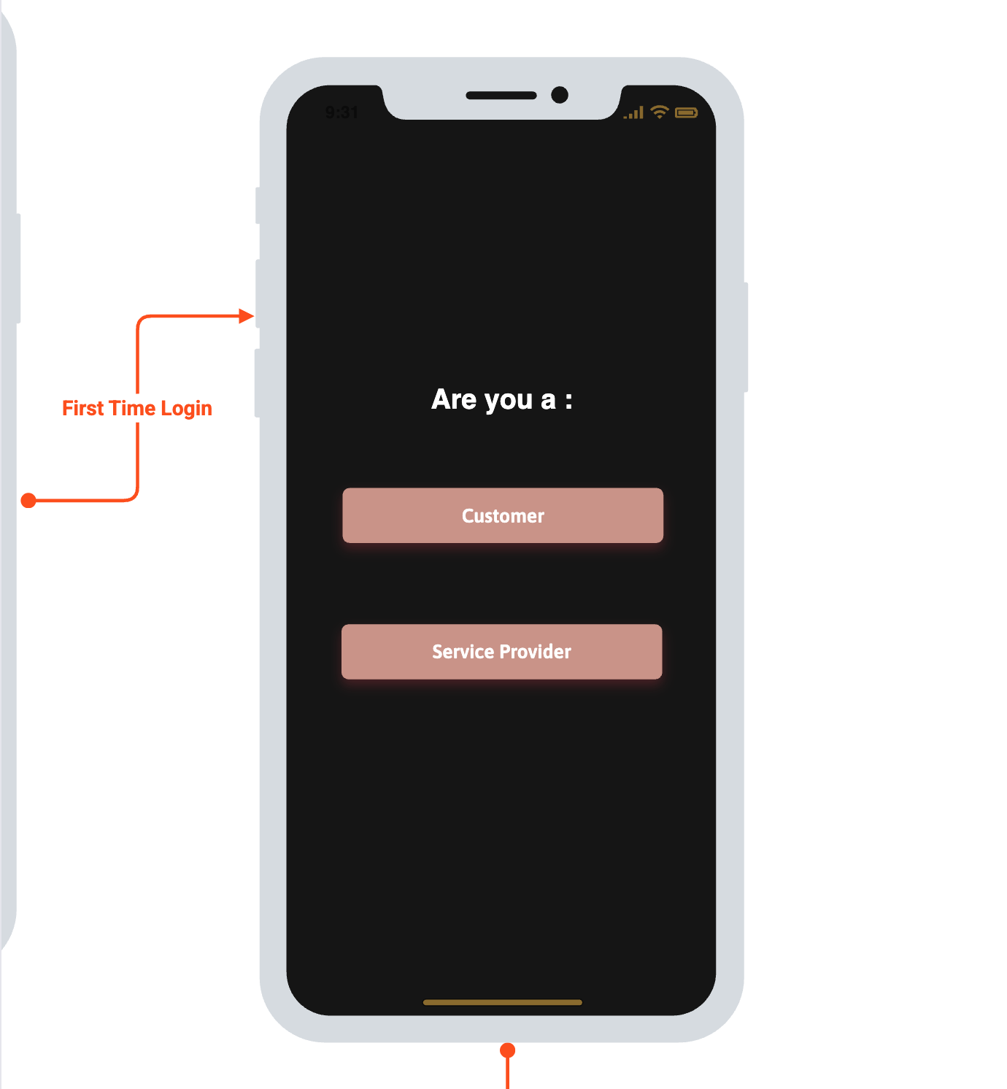

First Time login continued / user profile
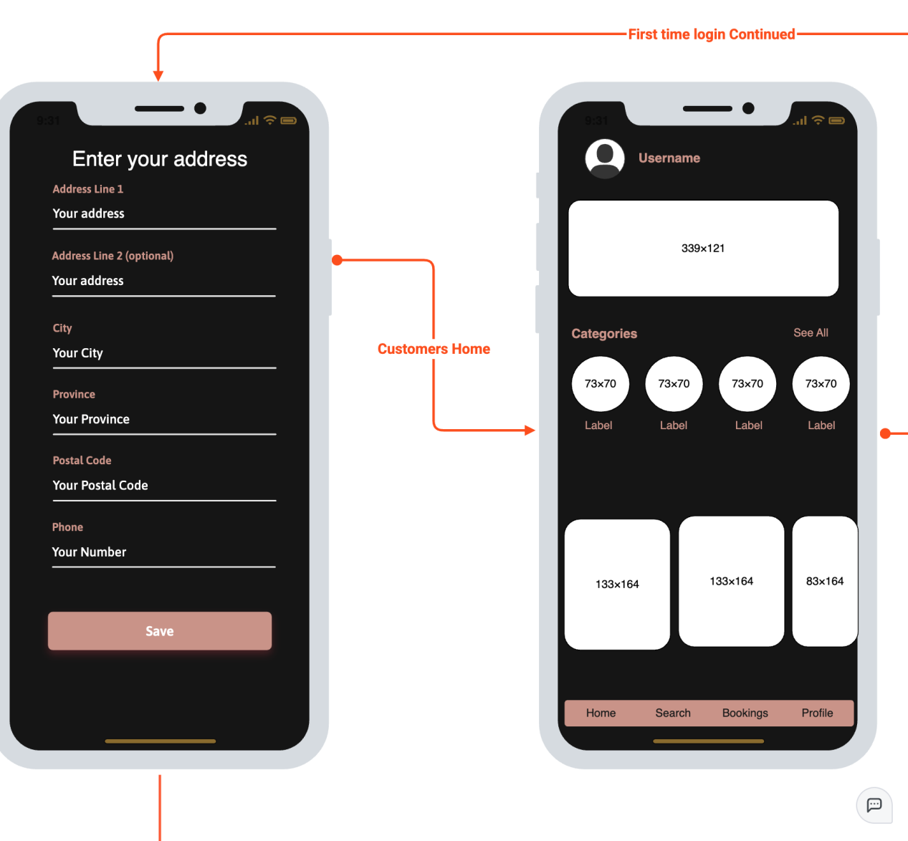

Search and Bookings

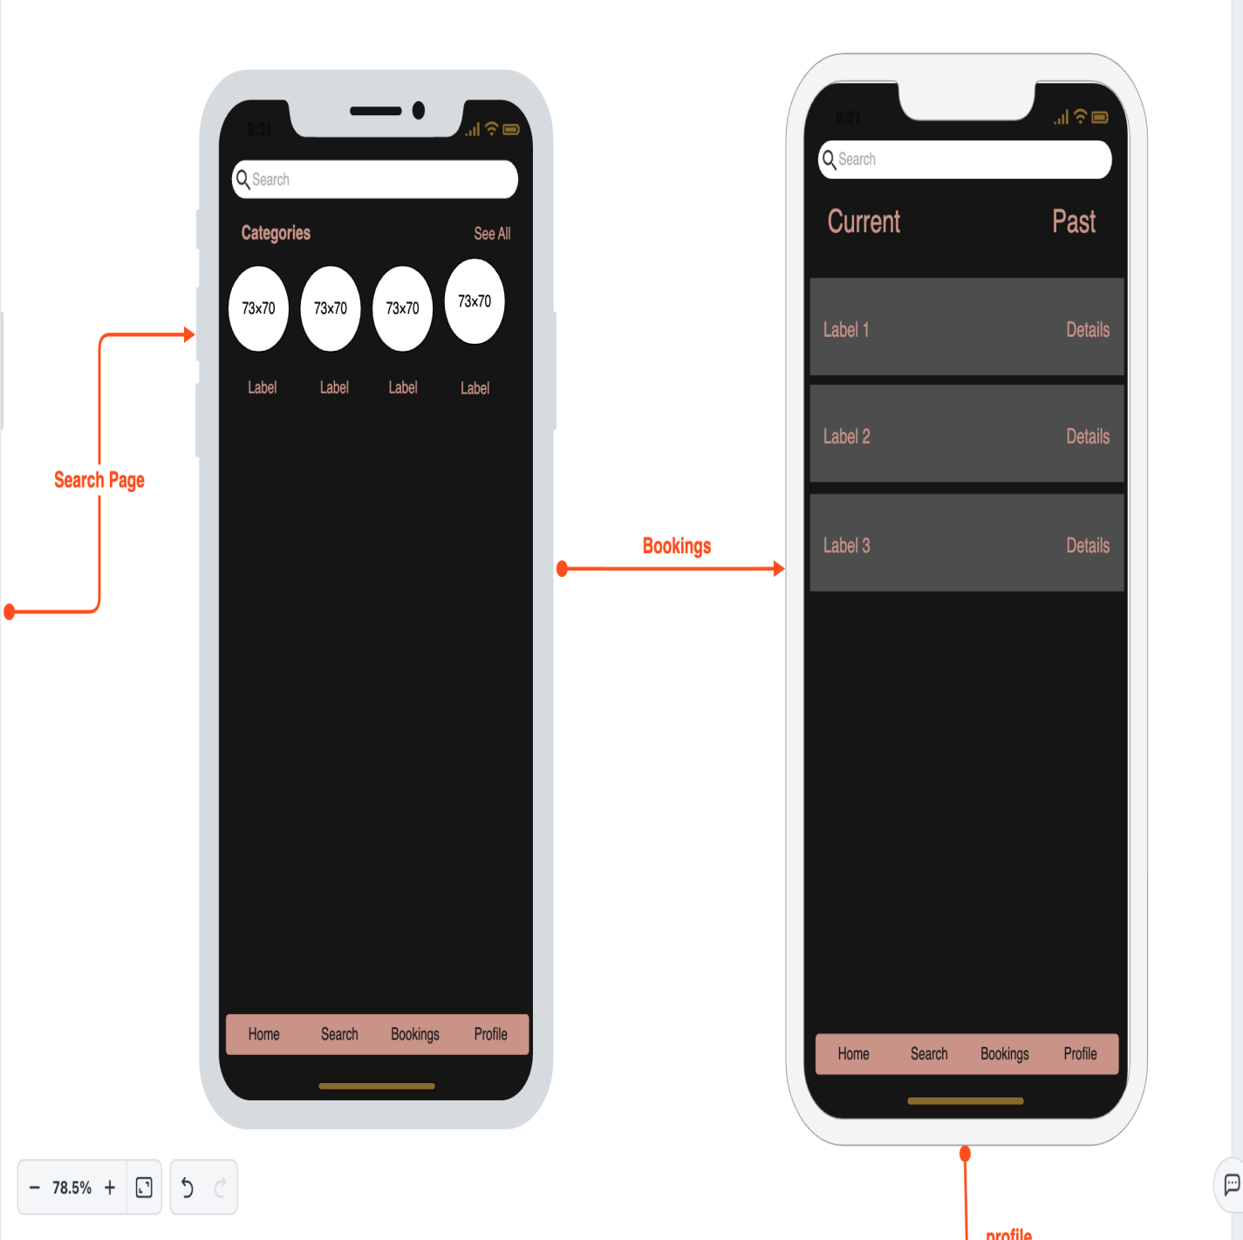

User profile
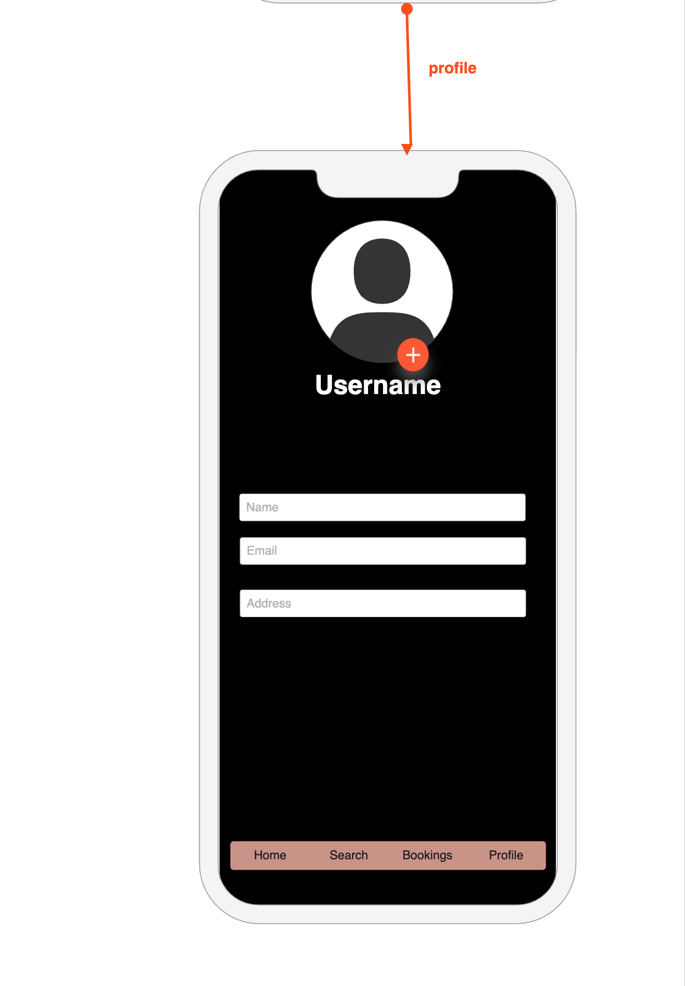

Professional’s profile

